

CAPSTONE PROJECT REPORT
Report 1 – Project Introduction

Table of Contents
I. Record of Changes 3
II. Project Introduction 4
1. Overview 4
1.1 Project Information 4
1.2 Project Team 4
2. Product Background 4
3. Existing Systems 5
3.1 KiotViet 5
3.2 Haravan 5
3.3 Sapo 5
4. Business Opportunity 6
5. Software Product Vision 6
6. Project Scope & Limitations 7
6.1 Major Features 7
6.2 Limitations & Exclusions 8

I. Record of Changes
Date | A*  M, D | In charge | Change Description
15/09/2025 | A | DuongNT | Added Project Information
15/09/2025 | M | DuongNT | Modified Product Background
16/09/2025 | M | HuyNX | Modified Project Team
17/09/2025 | M | DuongNT | Modified Overview
18/09/2025 | M | DuongNT | Modified Project Introduction
20/09/2025 | A | DatVV | Added Major Feature Diagram
24/09/2025 | M | NamNV | Modified Project Information
24/09/2025 | M | DuongNT | Modified Product Background
29/09/2025 | M | HuyNX | Modified Product Background
*A - Added M - Modified D - Deleted

II. Project Introduction

1. Overview

1.1 Project Information
- Project name: SnapBuy - Sales Management Software
- Project code: SSMS
- Group name: SEP490 - G127
- Software type: Web-based application

1.2 Project Team
Full Name | Role | Email | Mobile
Nguyen Thanh Y | Lecturer | ynt4@fe.edu.vn | 0934290389
Nguyen Van Nam | Leader | namnvhe176654@fpt.edu.vn | 0333248268
Nguyen Xuan Huy | Member | huynxhe171343@fpt.edu.vn | 0964133163
Vuong Van Dat | Member | datvvhe161402@fpt.edu.vn | 0983182809
Nguyen Tung Duong | Member | duongnthe172189@fpt.edu.vn | 0795245399
Nguyen Thuy Duong | Member | duongnthe182415@fpt.edu.vn | 0846985407

2. Product Background
SnapBuy was created to meet the growing need of small and medium-sized household appliance retailers in Vietnam for a stronger online presence. After the pandemic, e-commerce expanded rapidly, but many retailers still relied mainly on physical stores. This caused problems such as outdated inventory, slow order handling, and missed sales opportunities.
Specific data and evidence:
- Market Growth: Vietnam's e-commerce market is projected to reach $27.73 billion in 2025 and is forecasted to grow at a Compound Annual Growth Rate (CAGR) of 21.65% from 2025-2030. (Mordor Intelligence)
- Challenges for Small Retailers: Despite the market growth, more than 7,000 small sellers left the major e-commerce platforms in the first six months of 2025. (Vietdata Research) This was due to intense competition, rising platform fees, and a lack of resources for marketing. (VnExpress International)
- Post-Pandemic Shift: The pandemic accelerated the shift to online shopping, with an estimated 8 million new online consumers in Vietnam by mid-2021, and 55% of them coming from non-urban areas. (VietNamNet)
In early 2025, feedback from retailers showed a clear demand for a platform that supports real-time product updates, efficient order management, and useful analytics. They needed a simple yet powerful tool to modernize their sales process and better serve customers. SnapBuy was developed as the answer to these needs. It helps appliance retailers manage their products more effectively, improve customer satisfaction, and strengthen their competitiveness in a dynamic market.

3. Existing Systems

3.1 KiotViet
Description: KiotViet is a popular Vietnamese POS and inventory management software tailored for small and medium retailers, enabling seamless transition from physical to online sales with e-commerce extensions.
Link: KiotViet
System Actors: Retailers, store staff, customers, suppliers, accountants.
Features:
- Real-time inventory tracking across multiple store locations.
- POS integration for in-store and online orders.
- Basic e-commerce website builder and order management.
- Reporting tools for sales analytics and financial tracking.

3.2 Haravan
Description: Haravan is a Vietnam-based e-commerce platform designed specifically for small and medium-sized enterprises (SMEs), offering comprehensive tools for building online stores, managing multi-channel sales, and integrating with local services.
Link: Haravan
System Actors: Retailers, customers, logistics partners, marketing teams, payment providers.
Features:
- Multi-channel selling (website, social media, marketplaces like Shopee and Lazada).
- Real-time inventory management and order processing.
- Built-in marketing tools (email/SMS campaigns, SEO optimization).
- Integration with Vietnamese payment gateways (Momo, ZaloPay) and shipping services (GHTK, Viettel Post).

3.3 Sapo
Description: Sapo is a Vietnamese platform for small businesses, offering tools to build online stores, track sales, and manage marketing.
Link: Sapo
System Actors: Retailers, customers, suppliers, marketing staff.
Features:
- Easy website builder for online stores.
- Manages inventory and orders across multiple warehouses.
- Tools for promotions and customer management.
- Supports local payments (VNPAY, COD) and delivery services.

4. Business Opportunity
Vietnam’s e-commerce market is opening up a new horizon for small and medium-sized home appliance retailers, with a market value of 25 billion USD in 2024 and expected to reach 27.73 billion USD by 2025. This is a golden time for small businesses to take advantage of the wave of online shopping that is spreading across the country. However, many retailers are still facing major barriers: outdated management systems, from the use of traditional books to asynchronous software, leading to unauthenticated inventory, slow order processing, and reduced revenue, missing out on online customers. SnapBuy was born as a breakthrough solution, providing an integrated platform specifically designed for the Vietnamese market, helping retailers overcome these obstacles easily.
SnapBuy was developed to provide real-time inventory management, order automation to speed up transactions, and simple business analytics tools to predict shopping trends. The platform is not only cost-effective but also optimized to suit the needs of small businesses, with a friendly interface and reasonable costs. SnapBuy takes advantage of the latest trends, such as the popularity of mobile shopping and the rise of cashless payments (up 63.3% in the first half of 2024). Furthermore, SnapBuy connects directly to content-as-a-service transactions, helping retailers expand their reach, especially to areas outside of urban areas where demand is growing rapidly. In an increasingly competitive landscape, SnapBuy is not only a support tool but also a key for small businesses to grow, turn the potential of e-commerce into real profits and build a solid foundation for long-term growth.

5. Software Product Vision
SnapBuy was built with the mission of becoming a trusted companion, helping small and medium-sized home appliance retailers in Vietnam confidently step into the world of e-commerce without worrying about the complexity of technology. In a potential market, expected to exceed 62 billion USD by 2030, SnapBuy offers a comprehensive, "tailored" solution for Vietnamese businesses, seamlessly integrating with popular payment gateways and major e-commerce platforms.
The platform focuses on three core values: real-time inventory updates to ensure no sales opportunities are missed, fast order processing to improve customer satisfaction, and easy-to-understand analytical reports to support smart business decisions. With a simple and intuitive interface, SnapBuy helps even non-tech-savvy people to use it easily, saving time and minimizing errors. SnapBuy’s vision goes beyond solving current problems to empowering small retailers to compete with larger players, personalize customer experiences, and expand into new markets. SnapBuy is more than just a management software – it is a strategic partner that accompanies businesses on their digital transformation journey, helping them not only adapt but also lead the e-commerce race. With SnapBuy, small retailers can confidently turn challenges into opportunities, build a prosperous future, and contribute to shaping Vietnam’s promising e-commerce landscape.

6. Project Scope & Limitations

6.1 Major Features
Link diagram: Diagram
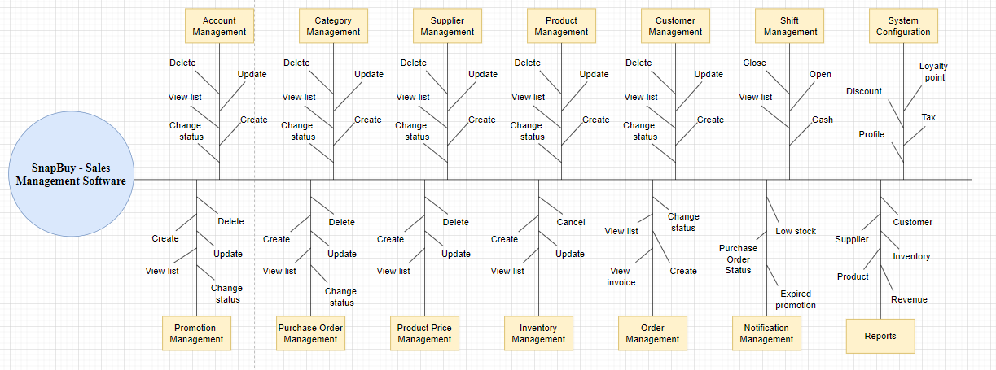
Figure 1.1: Feature Tree
# | Feature & Description
FE-01 | Create, view, modify, and delete sales data, including real-time stock updates and support for selling on websites, social media, and marketplaces.
FE-02 | Create, view, modify, and delete employee records for shop owners, including roles, permissions, and work schedules to manage teams.
FE-03 | Create, view, modify, and delete records of income and expenses, with tools to track payments and connect with local payment systems.
FE-04 | Create, view, modify, and delete customer profiles, including purchase history and promotions
FE-05 | Create, view, modify, and delete interest rate settings for financing or promotional plans tailored to retail needs.
FE-06 | Create, view, and modify reports on sales, stock, finances, and business performance to help make better decisions.
FE-07 | Create, view, modify, and delete shop owner accounts, allowing platform admins to manage multiple retailers and their subscriptions.
FE-08 | Create, view, modify, and delete orders for shop owners, including tracking and delivery integration with services like GHTK and Viettel Post.

6.2 Limitations & Exclusions
LI-1: No mobile app will be available; the platform will only work on web browsers for desktops and mobile devices.
LI-2: Advanced features like predicting stock needs or automatic pricing are not included.
LI-3: Support for international marketplaces or payment systems outside Vietnam is not included.
LI-4: The platform will only support Vietnamese and basic English, with no other languages.
LI-5: Integration with physical store hardware, like POS machines, is not part of this project.

